**DAILY ONLINE ACTIVITIES SUMMARY**

|  |  |  |  |  |  |  |  |  |
| --- | --- | --- | --- | --- | --- | --- | --- | --- |
| **Date:** | **16/06/2020** | | | | | **Name:** | **SHREEKIRAN R BHAT** | |
| **Sem & Sec** | **IV sem & B section** | | | | | **USN:** | **4AL18CS080** | |
| **Online Test Summary** | | | | | | | | |
| **Subject** | | **Complex Analysis, Probability and Statistical Methods** | | | | | | |
| **Max. Marks** | | **30** | | **Score** | | | **22** | |
| **Certification Course Summary** | | | | | | | | |
| **Course** | **Introduction to Information Security** | | | | | | | |
| **Certificate Provider** | | | **Greatlearning academy** | | **Duration** | | | **5.5 hours** |
| **Coding Challenges** | | | | | | | | |
| **Problem Statement1:** Write a Python program to check whether a given a binary tree is a valid binary search tree (BST) or not? | | | | | | | | |
| **Status: Executed** | | | | | | | | |
| **Uploaded the report in Github** | | | | | **YES** | | | |
| **If yes Repository name** | | | | | **Online-coding** | | | |
| **Uploaded the report in slack** | | | | | **YES** | | | |

Online Test Summary:18MAT41 test was scheduled from 3:00pm t0 3:40pm .The portion for the IA was 1st module there were 30 questions and the time assigned was 40 minutes the questions were mcq type.

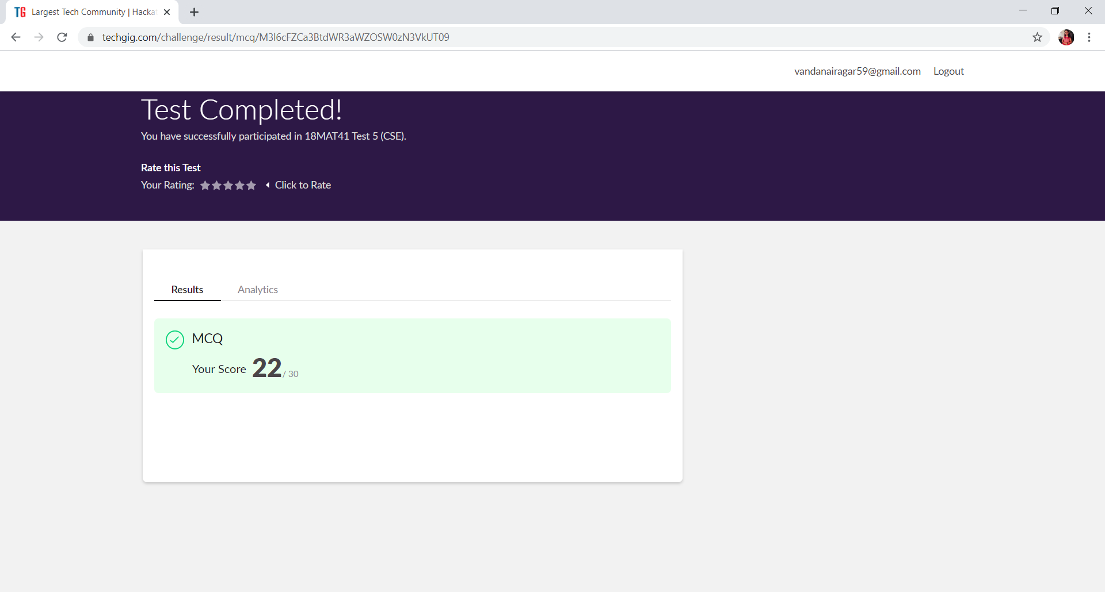

This is the completion of test and marks obtained for 18MAT41.

Online Certification Course Summary: Today I have enrolled for the course named Introduction to Information Security in today’s session I have learnt about how will be the future of cryptography and also how can we prevent data breaches.

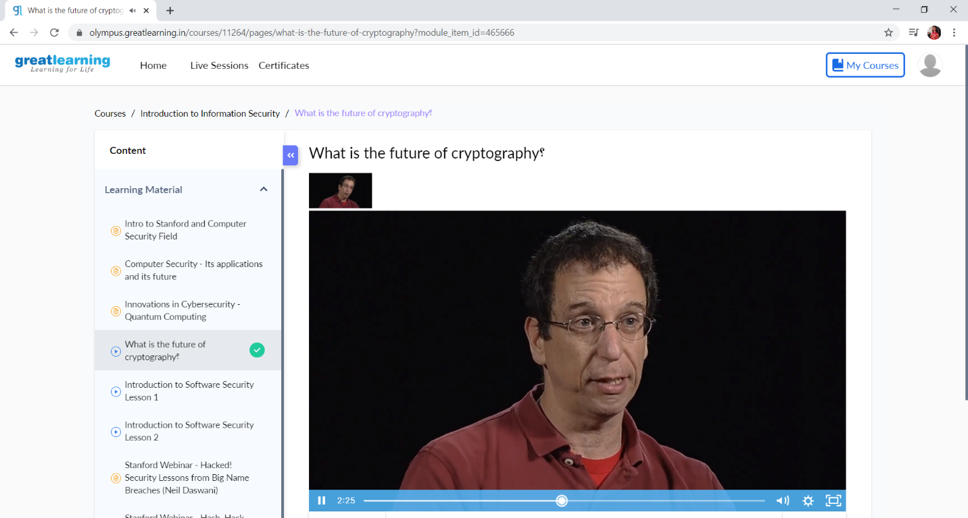

This is the Snap Shot of today’s session.

Online Coding Summary: **Today I had received one program from prof. Vasudev CSE Dept.The program is mentioned above in the coding challenges(pg.01). I have also uploaded it to my Github repository.**

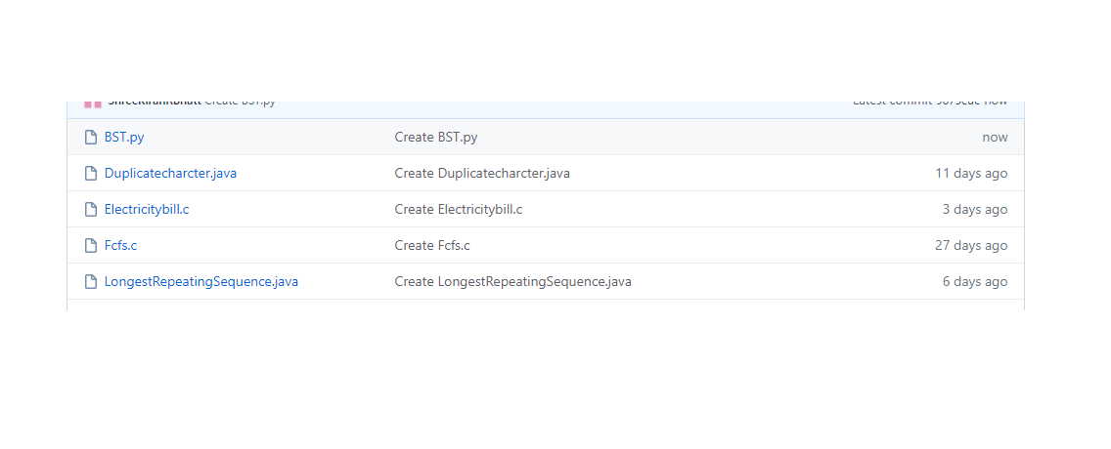

**This is the snap shot of my Github repository** were I have uploaded the code. File name is BST.py